Chapter:1
INTRODUCTION TO THE PROJECT
INTRODUCTION TO THE PROJECT
1.1 ABOUT THE PROJECT
AppSphere is a versatile Python based platform that integrates various applications to enhance productivity, entertainment, and user interaction. It includes a scientific calculator with a Tkinter GUI that supports both basic and advanced functions, featuring switchable modes and a resizable window. For gaming enthusiasts, there's a car racing game where players navigate a car to avoid collisions, and a "Dodge The Ball" game where players earn points by avoiding randomly moving balls. Additionally, AppSphere offers a Flappy Bird replica for a nostalgic gaming experience.
For productivity, Notacraft provides a lightweight text editor with essential functionalities like creating, opening, and saving documents, along with undo/redo actions. Artaura is a simple paint application that allows users to draw with various tools, save their work, and adjust brush sizes and colors.chatboenhances user interaction by performing tasks such as fetching weather updates, playing music, and providing news through voice commands. Overall, AppSphere demonstrates the versatility and capability of Python and its libraries in creating diverse and functional applications.
1.2 Problem defination
The problem addressed by AppSphere is the need for a unified platform that enhances user productivity, entertainment, and interaction through a variety of digital tools. Users often rely on multiple disparate applications for tasks such as advanced calculations, gaming, text editing, drawing, and voice assisted operations. Managing these separate applications can be cumbersome and inefficient. AppSphere solves this problem by integrating all these functionalities into a single, cohesive Python based platform, leveraging the power of Tkinter and Pygame libraries. This integration simplifies access, improves user experience, and demonstrates the versatility and capability of Python in creating multifunctional applications.
1.3 HISTORY
AppSphere was born out of a passion for creating a seamless digital experience that integrates productivity, entertainment, and user interaction into one comprehensive platform. The journey began with a series of standalone projects, each developed to address specific needs and to explore the capabilities of Python and its libraries.
The motivation for AppSphere stemmed from a common frustration: the inefficiency of using multiple separate applications for different tasks. As a developer and a user, I found myself constantly switching between various tools—a scientific calculator for complex calculations, text editors for note taking, simple games for quick breaks, and voice assistants for hands free interaction. This constant juggling was not only time consuming but also disrupted my workflow.
The idea of creating a unified platform started as a personal project, driven by the belief that a more streamlined and cohesive digital experience could significantly enhance productivity and user satisfaction. By integrating these diverse functionalities into a single platform, I aimed to simplify access, reduce the cognitive load, and provide a more enjoyable and efficient user experience.
The real turning point came with the realization that these individual projects, each useful and engaging in its own right, could be even more powerful if combined into a single platform. Thus, AppSphere was created, integrating these diverse applications to provide a unified and cohesive user experience.
AppSphere has proven to be a versatile and valuable tool, catering to a wide range of needs. For students and professionals, it offers powerful productivity tools like the scientific calculator and Notacraft. For moments of leisure, the integrated games provide quick and enjoyable distractions. The analog and digital clock displays add a touch of elegance to the desktop, while DrawMe offers a creative outlet. In essence, AppSphere simplifies the digital experience by bringing together essential tools and entertainment in one place, making it a true companion for both work and play. This project stands as a testament to the potential of Python and the creativity and dedication of its developers.

1.4 Methodology
The development of AppSphere follows a structured methodology to ensure the efficient and effective integration of its diverse applications. This methodology encompasses the following key phases: Planning, Design, Development and Testing.
1.4.1 Planning
- Requirement Analysis : Gather and analyze requirements for each component of AppSphere.Identify target audience and their needs for productivity, entertainment, and interaction tools.
- Feasibility Study : Evaluate the feasibility of integrating multiple applications within a single platform.Assess the technical, economic, and operational feasibility of the project.
- Project Scheduling : Develop a detailed project schedule, outlining milestones, deliverables, and deadlines for each phase.
1.4.2. Design
- System Architecture Design : Design the overall architecture of AppSphere, ensuring modularity and scalability.Define the interaction between different components (Calculator, Games, Notacraft, Artaura, Deskassist)
- User Interface Design : Create wireframes and prototypes for the graphical user interfaces of all applications. Ensure consistency in design elements across different applications to provide a unified user experience
- Database Design: Design a database schema if required for storing user data, preferences, and application states.
1.4.3. Development:
- Environment Setup: Set up the development environment, including Python, necessary libraries (Tkinter, Pygame, etc.), and version control systems (Git).
- Module Development: Develop the basic and advanced functions. Implement the Tkinter GUI with switchable modes and resizable window features.Develop game mechanics for car navigation and collision avoidance.Implement point earning logic and random ball movement. Recreate the mechanics of the original Flappy Bird game.functalities for creating, opening, and saving documents. Implement undo/redo actions. Develop drawing tools, saving functionality, and brush adjustments.Integrate voice command features for fetching weather updates, playing music, and providing news. Integrate all modules into a single platform.Ensure seamless interaction between different components.
1.4.3 Testing:
- Unit Testing: Conduct unit tests for individual functions and components to ensure they work correctly in isolation.
- Integration Testing: Test the interaction between integrated components to ensure they function together without issues.
- System Testing:Perform end to end testing of AppSphere to ensure it meets the requirements and performs well under various conditions.
1.4.4 Documentation and Reporting:Maintain comprehensive documentation throughout all phases, including requirement specifications, design documents, test cases, and user manuals.Regularly report progress to stakeholders and adjust the project plan as needed based on feedback and findings during development and testing.
By following this structured methodology, AppSphere ensures a systematic approach to developing a versatile and integrated platform, leveraging Python's capabilities to enhance productivity, entertainment, and user interaction.
1.5 Feasibility Study
AppSphere is a comprehensive platform designed to integrate various applications into one seamless, user friendly experience, enhancing productivity, entertainment, and user interaction.
1.5.1 Technical Feasibility: Python, with libraries like Tkinter and Pygame, provides robust tools for developing a diverse range of applications. From a scientific calculator to engaging games and utility tools, Python supports all necessary functionalities. The Deskassis desktop assistant uses additional libraries for voice recognition and synthesis, ensuring a technically sound platform.
1.5.2 Resource Feasibility: AppSphere requires minimal hardware resources, making it accessible for most computers. The development tools, including Python and its libraries, are freely available, keeping costs low. Skilled Python developers are readily available to bring the project to life.
1.5.3 Market Feasibility: There's a strong demand for applications like scientific calculators, casual games, utility tools, and personal assistants. While competition is high, AppSphere can stand out with unique features, a superior user interface, and the seamless integration of multiple functionalities, making it attractive to users.
1.5.4 Financial Feasibility: Development costs are low due to the use of open source tools. Potential revenue can come from ads, premium features, in app purchases, subscriptions, or affiliate marketing. The diverse functionalities offer multiple avenues for generating income.
1.5.5 Operational Feasibility: Ensuring a smooth and intuitive user experience is crucial. The scientific calculator should be responsive and easy to use. Games need to offer smooth gameplay and regular updates. Utility applications should be straightforward, with regular maintenance based on user feedback. Deskassis must be intuitive and responsive, with privacy and security measures in place.
1.5.6 Legal and Ethical Feasibility: Compliance with copyright laws and user privacy is essential. Adhering to licensing agreements for third party libraries ensures legal use. Secure and ethical handling of user data builds trust and credibility.

Chapter:2
PROJECT REQUIREMENTS ANALYSIS AND SPECIFICATIONS

PROJECT REQUIREMENTS ANALYSIS AND SPECIFICATIONS
To ensure the optimal performance and seamless functionality of AppSphere, both hardware and software requirements need to be met. The following list outlines the essential requirements:
2.1 Hardware Requirements
- Processor:
- Minimum: Dual Core Processor (2 GHz or faster)
- Recommended: Quad Core Processor (2.5 GHz or faster)
- Memory (RAM):
- Minimum: 4 GB
- Recommended: 8 GB or more
- Storage:
- Minimum: 500 MB of available disk space for application files and dependencies
- Recommended: 1 GB or more of available disk space for additional data storage
- Graphics:
- Minimum: Integrated Graphics with support for OpenGL 2.0
- Recommended: Dedicated Graphics Card with at least 1 GB VRAM
- Display:
- Minimum: 1280x720 resolution
- Recommended: 1920x1080 resolution or higher
- Audio:
- Sound Card and Speakers/Headphones (for Deskassist and gaming applications)

2.2 Software Requirements
- Operating System:
- Windows 7/8/10/11 (64 bit)
- macOS 10.12 or later
- Linux (any modern distribution, 64 bit)
- Python Environment:
- Python 3.8 or later
- Python Libraries:
- CustomTkinter (for GUI components)
- PIL/Pillow (for image processing)
- Pygame (for gaming applications)
- CustomTkinter (for advanced Tkinter components)
- SQLite3 (for database management)
- pyttsx3 ( Python library for text to speech conversion)
- speech_recognition(For recognizing speech input)
- pywhatkit (To play music from YouTube)
- Wikipedia( For fetching information from Wikipedia)
- Requests(For making HTTP requests, used for weather and news APIs)
- Random(For generating random elements)
- Datetime( For working with dates and times)
- Pyowm ( Python wrapper around OpenWeatherMap API)
- Development Tools:
- Integrated Development Environment (IDE) such as PyCharm, Visual Studio Code, or any preferred Python IDE
- Version Control System (Git)
- Additional Software:
- SQLite Database Browser (optional, for database management)
- Internet Browser (for documentation and online resources)
7. Networking:
- Internet Connection (for downloading dependencies and updates, fetching live data for Deskassist)
2.3 Detailed Description
2.3.1 Python Environment: Choosing a Python 3.8 or later environment for the application is essential for several reasons. Firstly, newer Python versions come with a range of improvements, including enhanced performance, security updates, and bug fixes. By using the latest Python version, the application can take advantage of these advancements, ensuring optimal performance and reducing the risk of vulnerabilities.
Moreover, modern libraries and frameworks often require newer Python versions to function correctly. As the Python ecosystem evolves, library maintainers update their code to leverage the latest language features and improvements. By using Python 3.8 or later, the application can seamlessly integrate with these libraries, unlocking access to a wide range of powerful tools and resources.
Additionally, choosing a recent Python version future-proofs the application against potential compatibility issues and ensures long-term support from the Python community. As older Python versions reach end-of-life status and cease to receive updates and support, maintaining compatibility becomes increasingly challenging. By using Python 3.8 or later, the application can remain compatible with the latest technologies and continue to benefit from ongoing community support and development efforts.

2.3.2 Libraries of python used in this project are:
2.3.2.1 TKINTER
Tkinter is the standard GUI (Graphical User Interface) toolkit that comes with Python. It is widely used for creating desktop applications with a graphical user interface. Tkinter provides a set of tools for constructing graphical interfaces that are both simple and powerful.
2.3.2.2 PYTTSX3
‘pyttsx3’ is a text to speech conversion library in Python. It allows developers to convert written text into spoken words. This can be useful in applications where you want the system to provide auditory feedback or create applications for individuals with visual impairments.
2.3.2.3 SPEECH_RECOGNITION
The ‘speech_recognition’ library in Python provides a simple and convenient way to perform speech recognition. It allows developers to capture audio from a variety of sources and recognize spoken words using different speech recognition engines.
2.3.2.4 PYWHATKIT
‘Pywhatkit’ is a Python library that provides a simple interface for automating various tasks on the web. It acts as a wrapper around other libraries and APIs, making it easy for users to perform actions like sending messages on WhatsApp, performing Google searches, playing YouTube videos, and more.
2.3.2.5 OS
The ‘os’ library in Python is a part of the standard library and provides a way to interact with the operating system. It offers functions for file and directory operations, as well as some system related functionality.
2.3.2.6 SUBPROCESS
The ‘subprocess’ module in Python provides a way to spawn new processes, connect to their input/output/error pipes, and obtain their return codes. It's a powerful tool for interacting with the system shell and executing external commands or scripts.
2.3.2.7 RANDOM
The ‘random’ module in Python is part of the standard library and provides functionalities for generating pseudo random numbers. It's commonly used in various applications, including simulations, games, and cryptography.
2.3.2.8 REQUESTS
The ‘requests’ library in Python is a popular HTTP library that simplifies making HTTP requests and working with APIs. It provides a high level interface for sending HTTP requests and receiving responses, making it easy to interact with web services.

2.3.2.9 PYOWM
‘PyOWM’ is a Python wrapper around the OpenWeatherMap (OWM) web API. It allows developers to access weather data from OWM and integrate weather information into their Python applications.
2.3.2.10 WEBBROWSER
The ‘webbrowser’ module in Python provides a high level interface to allow displaying web based documents to users. It allows you to open web browsers programmatically and perform various tasks related to web browsing.
2.3.2.11 DATETIME
The ‘datetime’ module in Python provides classes for working with dates and times. It allows you to manipulate and format dates and times, perform arithmetic with them, and retrieve information about dates and times.
2.3.2.12 PIL/Pillow
PIL/Pillow is used for image processing, allowing the application to handle various image related tasks like loading, manipulating, and displaying images.

2.3.3 Development Tools:
2.3.3.1 PyCharm: PyCharm, created by JetBrains, is a top-tier Integrated Development Environment (IDE) tailored for Python development. Its comprehensive suite of tools empowers developers to write, navigate, and debug code efficiently. With features like syntax highlighting, code completion, and real-time error detection, PyCharm enhances productivity and maintains code quality. The IDE's integrated debugger enables seamless troubleshooting, while its version control system integration simplifies code management and collaboration. PyCharm's support for web frameworks like Django and Flask, along with HTML, CSS, and JavaScript tools, caters to web development needs. Additionally, it offers SQL editing and schema management for database tasks. PyCharm automates repetitive tasks, ensuring a smooth development workflow. Its extensibility through plugins allows customization to suit individual preferences. With project management features and support for virtual environments, PyCharm handles large-scale projects effectively. Whether you're a beginner or an expert, PyCharm provides the functionality and flexibility required for efficient Python development.
2.3.3.1.1 Key Features of Pycharm :
1. Code Editor: PyCharm offers a smart code editor with features like syntax highlighting, code completion, and code analysis to enhance productivity.
2. Debugger: It includes an integrated debugger that allows developers to debug Python code easily.
3. Testing Support: PyCharm supports various testing frameworks such as unittest, pytest, and doctest, enabling developers to write and run tests seamlessly.
4. Version Control Integration: PyCharm has built in support for version control systems like Git, Mercurial, Subversion, and CVS. This integration allows developers to perform version control operations directly from the IDE.
5. Database Tools: It provides tools for working with databases, including SQL code completion, database explorer, and data editor.

2.3.3.1.2Benefits of Using PyCharm
- Productivity: Enhances productivity with intelligent code assistance, automation of repetitive tasks, and powerful debugging tools.
- Quality: Improves code quality through real-time error detection, code inspections, and adherence to coding standards.
- Efficiency: Streamlines development workflows with integrated tools for version control, testing, and deployment.
- Versatility: Supports a wide range of development activities, from web and database development to data science and machine learning.
2.3.3.1.3Getting Started with PyCharm
- Installation: Download and install PyCharm from the JetBrains website. Choose between the Community edition (free) and the Professional edition (paid with additional features).
- Creating a Project: Start a new project by selecting a project type and configuring the project environment, such as setting up a virtual environment.
- Writing Code: Use the intelligent code editor to write and manage Python code, leveraging features like code completion and navigation.
- Running and Debugging: Execute code and use the integrated debugger to identify and fix issues.
- Version Control: Set up version control integration to manage code changes and collaborate with others.
2.3.3.2 Visual Studio Code (VS Code): Visual Studio Code (VS Code)is a versatile and highly customizable code editor developed by Microsoft. Renowned for its lightweight yet powerful design, VS Code caters to a wide array of programming languages and developer preferences. Its key strength lies in its extensibility, boasting a rich ecosystem of extensions that augment its capabilities to suit individual needs. With features like IntelliSense for code completion and syntax highlighting, developers can write code with efficiency and precision. The integrated terminal provides seamless access to command line tools without leaving the editor, streamlining the development workflow. Sure, let's delve into each one:
2.3.3.2.1 Key Features of Visual Studio Code:
1. Customizable Interface : VS Code allows users to customize the editor's layout, themes, and keyboard shortcuts according to their preferences.
2. IntelliSense: It provides intelligent code completion, syntax highlighting, and code suggestions for various programming languages, including Python.
3. Extensions: VS Code has a vast ecosystem of extensions available through the Visual Studio Code Marketplace. These extensions enhance the editor's functionality, adding support for additional languages, tools, and integrations.
4.Integrated Terminal: It features an integrated terminal within the editor, allowing developers to run command line tools and scripts without leaving the IDE.
5.Debugging: VS Code includes built in debugging support for multiple programming languages, including Python. Developers can debug their Python code directly within the editor using breakpoints, watches, and variable inspection.
2.3.3.2.2 Visual Studio Code (VS Code) offers several benefits for developers:
- Cross-platform Compatibility: VS Code is available for Windows, macOS, and Linux, allowing developers to use the same editor across different operating systems.
- Lightweight and Fast: It is a lightweight editor with fast performance, making it suitable for both small scripts and large projects.
- Extensive Language Support: VS Code supports a wide range of programming languages out of the box, and its rich ecosystem of extensions further extends its capabilities for specific languages and frameworks.
- Integrated Terminal: The integrated terminal allows developers to run commands, scripts, and utilities without leaving the editor, streamlining the development workflow.
- Built-in Git Integration: VS Code comes with built-in Git support, enabling developers to manage version control directly within the editor, including features like staging changes, committing, and pushing to remote repositories.
- Customizable: VS Code offers extensive customization options, including themes, keyboard shortcuts, and settings, allowing developers to tailor the editor to their preferences and workflow.
- Debugging Support: It provides robust debugging capabilities with support for various debuggers, breakpoints, watch variables, and call stacks, making it easier to identify and fix issues in code.
2.3.3.2.3 To install Visual Studio Code:
- Download: Visit the official Visual Studio Code website (https://code.visualstudio.com/) and download the installer for your operating system.
- Run Installer: Once the installer is downloaded, run it and follow the installation instructions.
- Launch VS Code: After installation, launch Visual Studio Code from your applications menu or by clicking on its icon.
- Extensions: Explore and install extensions from the VS Code Marketplace to enhance your development experience. Extensions provide additional features and support for specific languages, frameworks, and tools.
- Customization: Customize VS Code according to your preferences by adjusting settings, installing themes, and configuring keyboard shortcuts.
2.3.3.3 GitHub:
GitHub is a web based platform and cloud service for hosting and managing Git repositories. It provides a collaborative environment for software development projects, enabling developers to work together, share code, and track changes efficiently.

2.3.3.3.1 Key Features of GitHub:
1. Git Repository Hosting: GitHub allows users to create and host Git repositories for their projects. Developers can push their code to GitHub repositories, making it accessible to collaborators and contributors.
2. Collaboration Tools: GitHub offers various collaboration tools, including pull requests, code reviews, issue tracking, and project boards. These tools facilitate communication and coordination among team members working on a project.
3. Version Control: As a Git based platform, GitHub provides robust version control capabilities, allowing developers to track changes, revert to previous versions, and manage code branches effectively.
4. Community and Social Features : GitHub has a large community of developers, and it fosters collaboration and knowledge sharing through features like public repositories, wikis, and discussions.
5. Continuous Integration/Continuous Deployment (CI/CD): GitHub integrates with CI/CD services like GitHub Actions, allowing developers to automate build, test, and deployment workflows directly from their repositories.
2.3.3.3.2 GitHub offers numerous benefits for both individual developers and teams:
- Version Control: GitHub provides a robust version control system based on Git, allowing developers to track changes to their codebase, revert to previous versions, and collaborate on code with ease.
- Collaboration: GitHub fosters collaboration among developers by providing features such as pull requests, code reviews, and issue tracking. These tools facilitate communication, code sharing, and teamwork, leading to more efficient development workflows.
- Project Management: GitHub offers project boards, milestones, and task tracking tools to help teams organize and manage their projects effectively. This enables teams to prioritize tasks, track progress, and coordinate efforts towards project goals.
- Code Quality: With features like code reviews, automated testing, and continuous integration, GitHub helps maintain high code quality standards. Developers can review each other's code, detect errors early, and ensure that code changes meet project requirements.
- Community and Networking: GitHub hosts a vibrant community of developers, open-source projects, and organizations. By contributing to open-source projects, developers can showcase their skills, learn from others, and build professional connections within the tech community.
- Visibility and Recognition: GitHub provides a platform for developers to showcase their work, share projects, and receive feedback from peers. Contributing to popular projects or maintaining your own repositories can enhance your visibility, reputation, and career prospects in the software industry.

2.3.3.3.3 Installing GitHub is straightforward:
- Create a GitHub Account: Visit the GitHub website (https://github.com/) and sign up for a free account by providing your email address, username, and password.
- Download Git: Before using GitHub, you need to install Git on your computer. Git is a version control system that GitHub is built upon. You can download Git from the official website (https://git-scm.com/) and follow the installation instructions for your operating system.
- Install GitHub Desktop (Optional): GitHub Desktop is a graphical user interface (GUI) application that simplifies the process of working with Git and GitHub repositories. You can download GitHub Desktop from the GitHub website and install it on your computer.
- Set Up SSH Keys (Optional): To securely interact with GitHub repositories from your local machine, you can set up SSH keys. This involves generating SSH keys on your computer and adding them to your GitHub account. GitHub provides detailed instructions for setting up SSH keys in their documentation.

2.3.4 Networking:
Internet Connection: A reliable internet connection is crucial for various aspects of the application. It is necessary for downloading dependencies and updates, ensuring that the application has access to the latest versions of libraries and tools. Additionally, many functionalities, such as fetching weather updates using the pyowm library, obtaining information from Wikipedia, and playing YouTube music with pywhatkit, require real time data access. An internet connection enables the application to interact with online APIs, providing users with up to date information and features. This enhances the application's functionality and user experience, making it more dynamic and responsive to real time events.

Chapter: 3
PROJECT DESIGN
3.1 Preliminary Design
The flowchart represents the user interaction and application flow for a software system that includes user authentication (sign up, login, forgot password) and a selection of applications (Calculator, Paint, Notepad, Dodge the Car, Dodge the Ball, Flappy Bird, DeskAssist).
Detailed Flow:-
1. Start : The process begins at the "Start" point.
2. Sign Up :The user is given an option to sign up for the system.
- Validate Sign Up : The system validates the information provided by the user.
- Process Sign Up : If the information is valid, the system processes the sign up request, creating a new user account.
3. Select Option : After the sign up process, the user is directed to a selection screen where they can choose to either log in or recover a forgotten password.
4. Forgot Password Flow : If the user selects "Forgot Password":
- Forgot Password : The user initiates the password recovery process.
- Recover : The user provides necessary recovery information (e.g., email).
- Validate Forgot Password : The system validates the recovery information.
- Process Forgot Password : If valid, the system processes the request, allowing the user to reset their password.
5. Login Flow : If the user selects "Login":
- Login : The user provides login credentials.
- Validate Login : The system validates the provided credentials
- Process Login : If the credentials are correct, the system processes the login request and grants access.

6. Welcome Screen : After a successful login, the user is presented with a welcome screen.
7. Select Application : The user is given a list of applications to choose from:
- Calculator
- Paint
- Notepad
- Dodge the Car
- Dodge the Ball
- Flappy Bird
- chatbot
8. End : The process concludes once the user selects an application to interact with.
Summary:
- Sign Up : Users can create an account.
- Forgot Password : Users can recover their accounts if they forget their password.
- Login : Users can access their accounts.
- Welcome Screen : Users are greeted after logging in.
- Select Application : Users can choose from a variety of applications to use.

This flowchart outlines a structured approach to user authentication and application selection, ensuring a smooth user experience from start to finish.

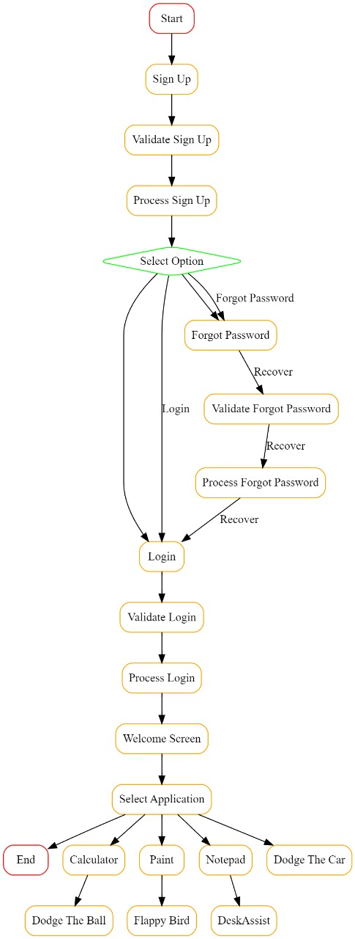
chatbot
3.2 Data Flow Diagram (DFD) :-This DFD represents a high-level overview of the user authentication and application interaction system. This can be considered as a Level 1 DFD, showing the primary processes, data stores, and data flows within the system. highlighting the processes involved in user authentication and the interaction with various applications. It illustrates how user information is handled securely and how application data is managed, providing a clear overview of the system's functionality and data management.
3.2.1 Main Code (Process 0)
1. MainCode :Central controller process that initiates user interactions and application processes .Coordinates user login, signup, and password reset requests.
2. Login :Accepts user login information.Verifies user credentials.If verified, authenticates the user and grants access to the system.
3. Signup :Collects new user information.Verifies the information.Saves user information into the User Database.Authenticates the user upon successful signup.
4. ForgotPassword :Handles password reset requests.Verifies user identity.Updates the password in the User Database.Authenticates the user after password reset.
3.2.2 App Sphere (Process 1)
Main interface for accessing different applications.Manages data flow between applications and data stores.
1. User Database :Stores user information including login credentials and profile data. Interacts with processes for saving, verifying, and updating user data.
2. App Data :Stores data related to various applications and Includes game progress, notes, drawings, calculations, and settings also Interacts with application processes for saving and retrieving application-specific data.
This Level 1 DFD captures the essential components and data flows of the system.
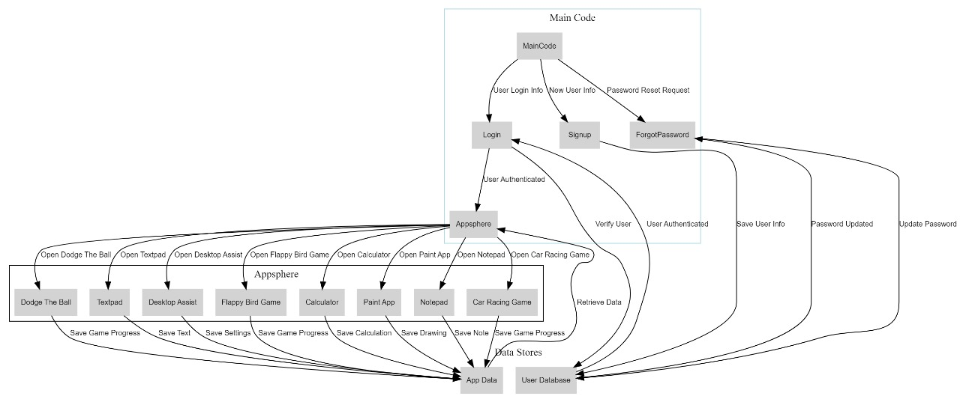3.3 Database using sqlite:-
This project involves creating a user management system using SQLite as the database engine. The system supports user registration, login, password reset, and data display. Below is a detailed description of the database functions implemented in the project.
- To use sqlite3 first install it in terminal : The sqlite3 module is included in the Python Standard Library, so you do not need to install it separately if you have Python installed. However, if you are using a virtual environment or a distribution of Python that does not include it, you can install it using pip:

- Import sqllite3 module: Once SQLite3 is installed, you can use it in your Python scripts by importing the module. This is done with a simple import statement.
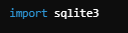
- Create a Connection to the Database using any file we have used “users.db”: This function establishes a connection to the SQLite database named `users.db` and returns the connection object.
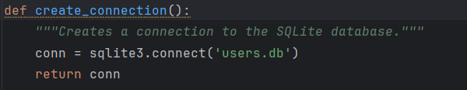
- Code to create a table in program: This function creates the `users` table if it does not already exist. It defines the schema with all the specified columns and constraints.
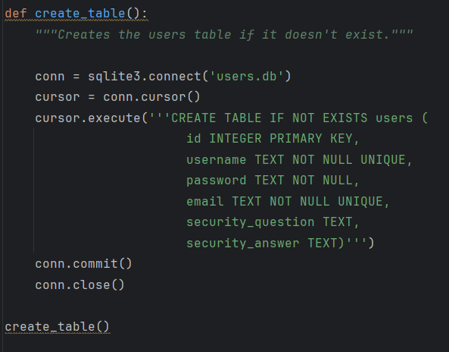
- In games the high score is stored by highscore.txt:
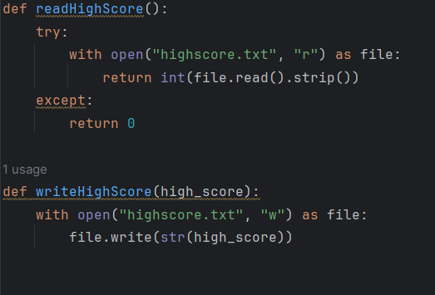
The diagram shows the structure of the users table, highlighting the column names and their data types along with constraints such as PRIMARY KEY, NOT NULL, and UNIQUE.
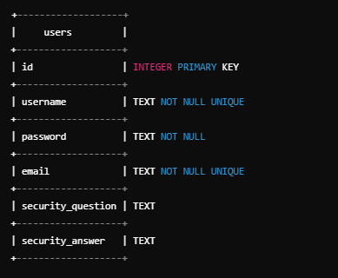
3.3.1 Database Schema Explanation : The database consists of a single table named `users` with the following columns:
3.3.1.1 Total Columns : This table is designed to store user information securely and uniquely. Each user is identified by a unique id which auto-increments. The username and email must be unique and provided by every user, ensuring no duplicates. The password is mandatory for security purposes, while the security_question and security_answer fields are optional and can be used for account recovery.
- id (INTEGER PRIMARY KEY) :
- This column is an integer that uniquely identifies each user in the table.
- The `PRIMARY KEY` constraint ensures that the value in this column is unique and not null. It also auto-increments with each new entry.
- username (TEXT NOT NULL UNIQUE) :
- This column stores the username of the user.
- The `NOT NULL` constraint ensures that this column cannot have null values.
- The `UNIQUE` constraint ensures that each username is unique across the table.
- password (TEXT NOT NULL) :
- This column stores the password of the user.
- The `NOT NULL` constraint ensures that this column cannot have null values.
- email (TEXT NOT NULL UNIQUE) :
- This column stores the email address of the user.
- The `NOT NULL` constraint ensures that this column cannot have null values.
- The `UNIQUE` constraint ensures that each email is unique across the table.
- security_question (TEXT) :
- This column stores the security question chosen by the user for password recovery.
- There are no constraints, so this column can be null.
- security_answer (TEXT) :
- This column stores the answer to the security question.
- There are no constraints, so this column can be null.
3.3.1.2 Total Rows: The number of rows will increase as more users sign up through the sign-up page.
Assume the `users` table contains the following rows:
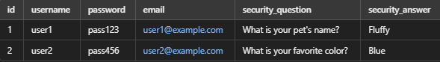

3.3.2 Constraints Summary
These constraints—Primary Key, Unique, and Not Null—work together to ensure data integrity, uniqueness, and completeness in the user table. They provide a robust mechanism for maintaining the quality and reliability of the data stored in the database, which is essential for the proper functioning of any application relying on this data.
- Primary Key Constraint : Primary Key Constraint ensures that the column it is applied to has unique and non-null values. It combines two main constraints: `UNIQUE` and `NOT NULL`. This constraint is essential for uniquely identifying each record in a database table.

Syntax:-
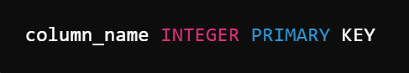
Example:-
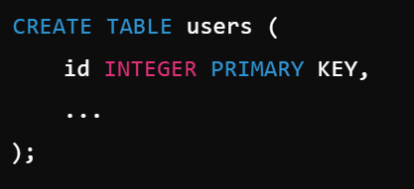

- Unique Constraints : Unique Constraints ensure that the values in the specified column(s) are unique across the table. This constraint is critical for maintaining the uniqueness of data where it is applied. Guarantees that no two rows can have the same value in the specified column(s). Prevents duplicate entries, ensuring data integrity.In our user table, `username` and `email` columns are constrained to be unique.
Syntax:-
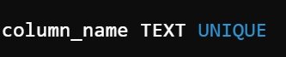
Example:-
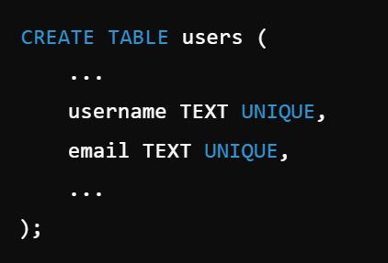

- Not Null Constraints : Not Null Constraints ensure that the specified column cannot contain `NULL` values. This constraint is essential for maintaining data integrity by ensuring that necessary data is always provided . Guarantees that every row must have a value in the specified column. Prevents the insertion of records with missing essential information. In our user table, the `username`, `password`, and `email` columns are constrained to be `NOT NULL`.
Syntax:-
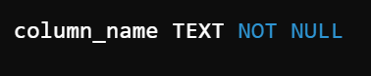
Example:-
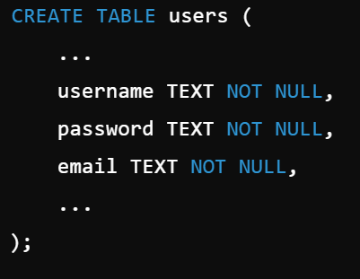

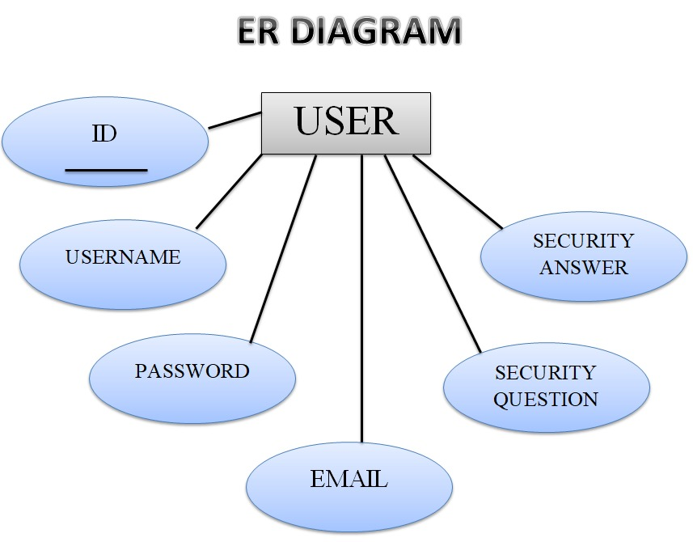

The ER diagram represents a single entity, "User", and its attributes in a visual format. Here is a detailed explanation of the diagram:
- Entity:
- User (Rectangle):
This rectangle represents the "User" entity in your database.
- Attributes:
id (PK) (Ellipse):
This is the primary key attribute of the "User" entity. It uniquely identifies each user.
- username (Ellipse):
This attribute stores the username of the user.
- password (Ellipse):
This attribute stores the password of the user.
- email (Ellipse):
This attribute stores the email address of the user.
- security_question (Ellipse):
This attribute stores the security question for the user.
- security_answer (Ellipse):
This attribute stores the answer to the security question.
- Connections:
- Lines:
The lines connect each attribute to the "User" entity, indicating that these attributes belong to the "User" entity.
- Diagram Layout:
The "User" entity is centrally located, with the primary key attribute "id (PK)" directly below it.
The other attributes (username, password, email, security_question, security_answer) are placed around the "User" entity, each connected by a line.
This diagram visually organizes the structure of the "User" table from your SQLite database, showing how each attribute is associated with the entity.

Chapter:4
PROJECT IMPLEMENTATION
4.1 Implementation
The implementation phase is a critical step in transforming the detailed requirements and design specifications into a functional and integrated multi functional platform. This phase involves the actual coding, integration, and deployment of all identified components—scientific calculator, games, text editor, paint application, and desktop assistant—into a unified application.
The goal of this phase is to develop a robust, scalable, and user friendly platform that meets all functional and non functional requirements. The implementation process will be guided by best practices in software development, ensuring that the code is clean, maintainable, and extensible. Additionally, the use of SQLite for data management will ensure efficient handling and storage of user data across the different functionalities.
This document outlines the structured approach to be followed during the implementation phase, including key activities such as setting up the development environment, coding standards, version control, integration processes, and testing methodologies. The implementation plan ensures that all components are developed cohesively, integrated seamlessly, and thoroughly tested to deliver a high quality platform that provides an excellent user experience.
4.2 App Development
App development is a crucial phase in bringing the envisioned multi functional platform to life. This phase involves the actual coding, integration, and deployment of various components, ensuring they work together seamlessly to provide users with a cohesive experience. The goal is to develop a robust, user friendly platform that encompasses a scientific calculator, games, a clock display, a text editor, a paint application, and a chatbot.
4.3 SNAPSHOTS OF PROJECT:-
4.3.1 Opening window : The overall design is playful and engaging, using the panda character to create a friendly and approachable interface for users. The different panda illustrations suggest that Appsphere offer a range of services or features catering to various user needs. Opening window offers multiple options
- Sign Up: Likely for new users to create an account.
- Login: For existing users to access their accounts.
- Forgot Password: For users who need to recover or reset their password.
- Exit: To close or exit the application
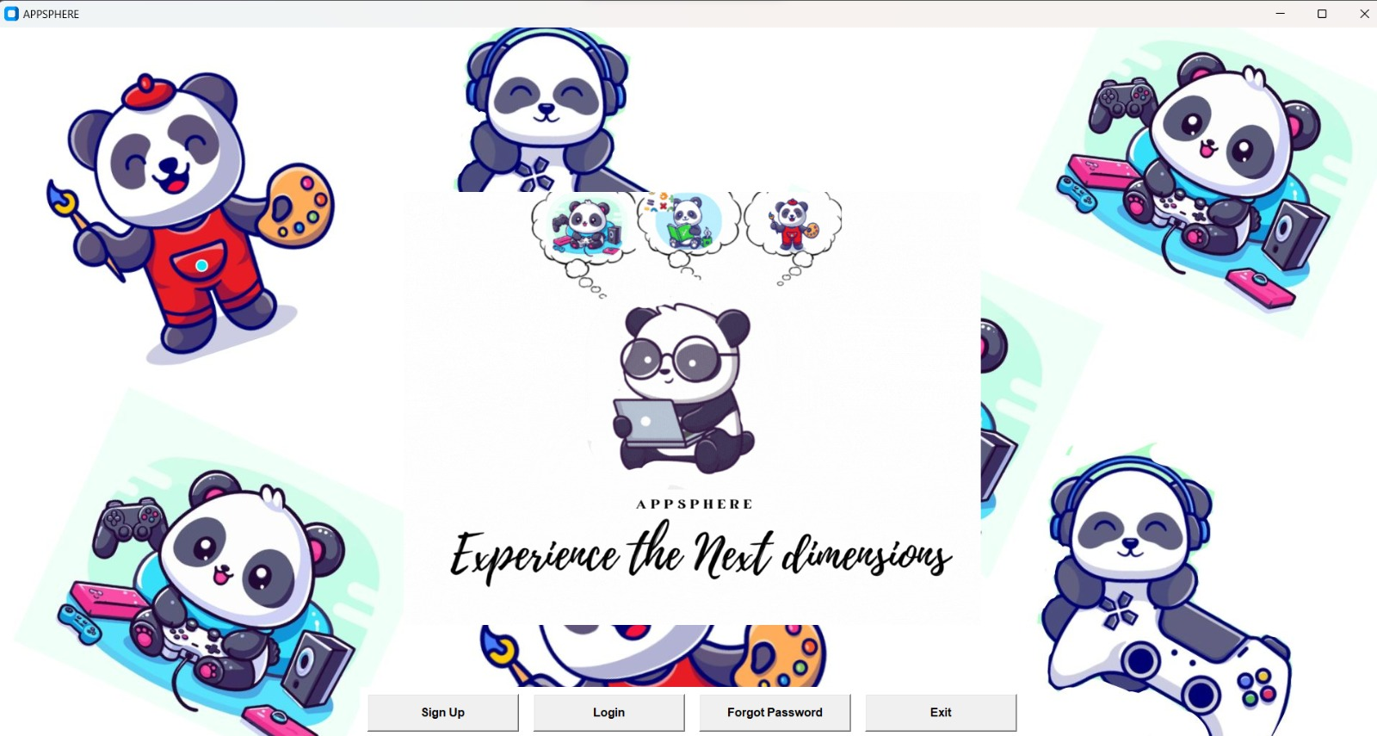
4.3.2 Sign up :The design is consistent with the previous login page, using cute panda characters to create an inviting and user-friendly interface. The use of pandas and bamboo gives the page a cohesive and themed appearance, likely intended to make new users feel comfortable and encouraged to sign up. There are several fields for users to fill in their information:
- Username: A field for entering a desired username.
- Email: A field for entering an email address, likely used for account verification and communication.
- Security Question: A field for selecting or entering a security question, which can be used for account recovery.
- Security Answer: A field for providing the answer to the selected security question.
- Password: A field for entering a password, with an eye icon that suggests an option to toggle the visibility of the entered password for easier verification.

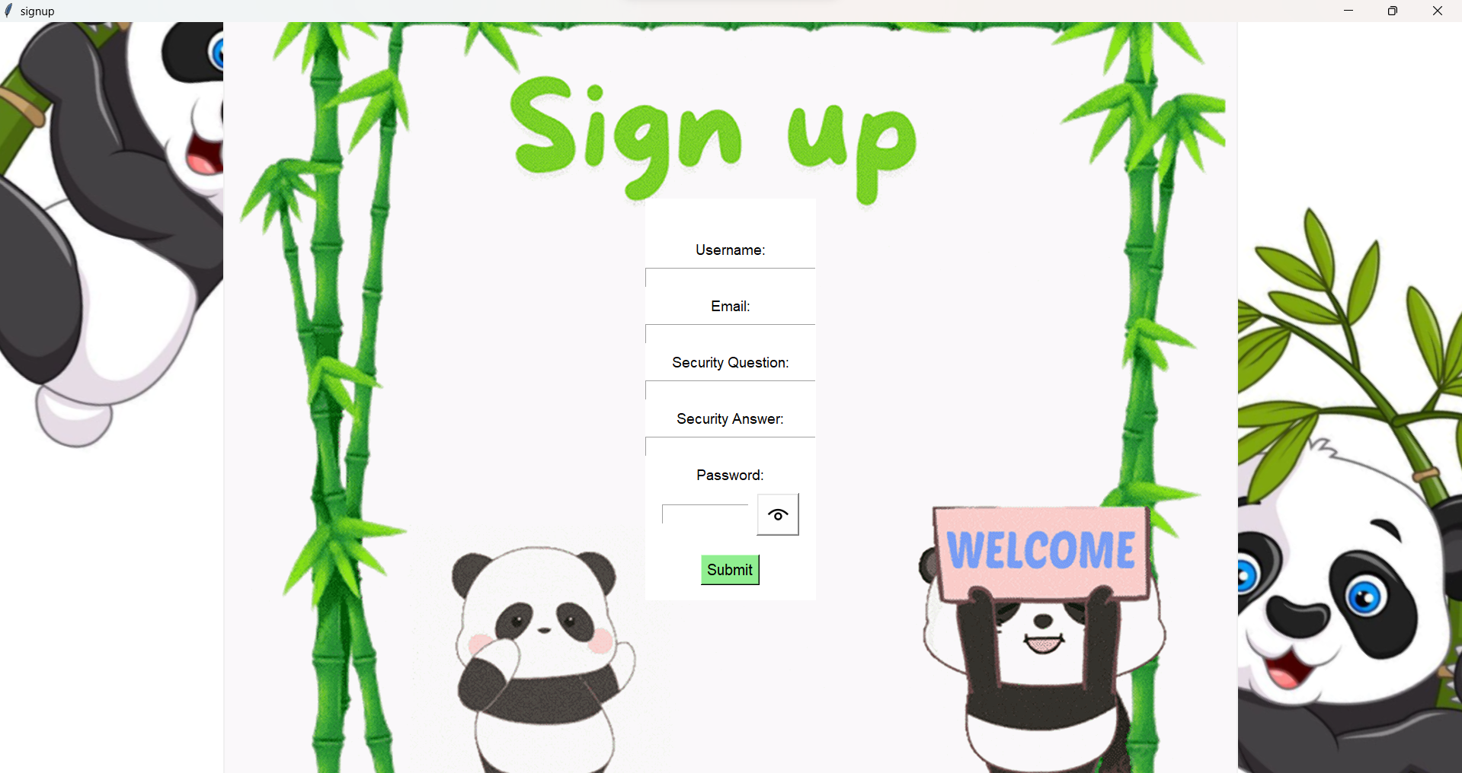
4.3.3 When user is successfully registerd : The notification dialog box indicating the successful completion of a user registration processThis notification serves as a positive confirmation to the user that their registration was successful, providing a clear and immediate feedback response to their action.
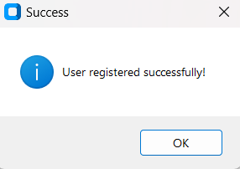
4.3.4 Log in page: The design is consistent with the previous main page and signup page using cute panda characters to create an inviting and user-friendly interface. The use of pandas and bamboo gives the page a cohesive and themed appearance, likely intended to make new users feel comfortable and encouraged to sign up. There are several fields for users to fill in their information:
- Username: A field for entering a desired username.
- Password: A field for entering a password, with an eye icon that suggests an option to toggle the visibility of the entered password for easier verification.

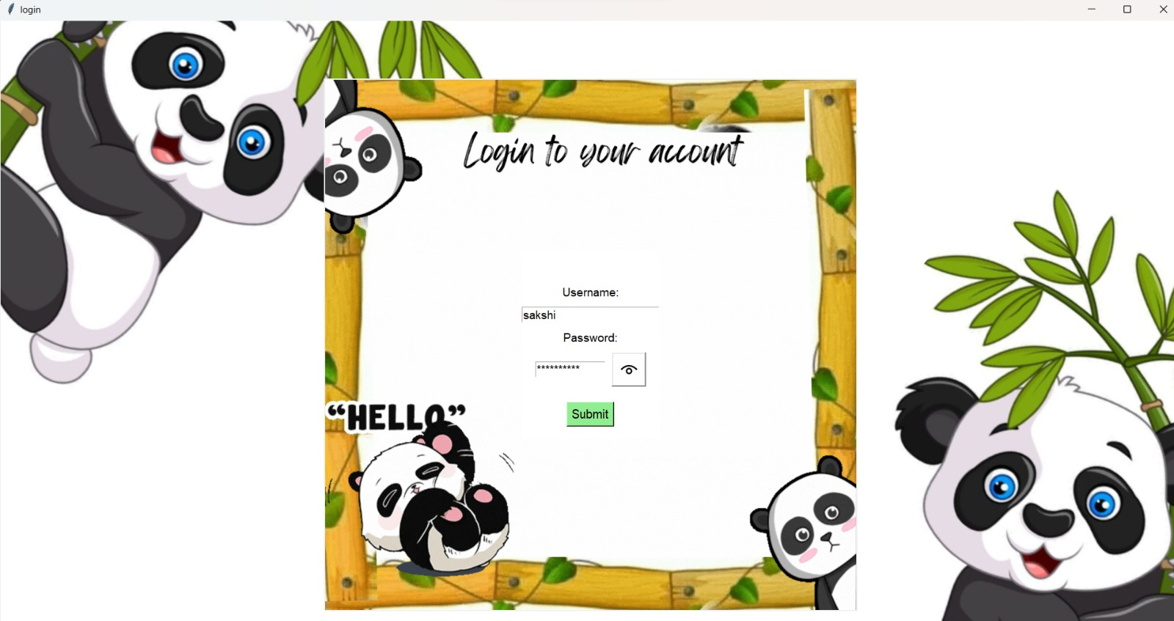
If the user is registerd in the database then user can register other wise a message box appears with message as given below:
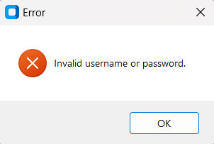

4.3.5 Main window: With help of Python tkinter we have made the design is consistent with the previous main page and signup page using cute panda characters to create an inviting and user-friendly interface. The use of pandas and bamboo gives the page a cohesive and themed appearance, likely intended to make new users feel comfortable and encouraged to use this the main window consist of 7 small project these are clickable screenshot when you click on a screenshot it will make you redirect to the app you want to open.
Options available are:
- Calculator: A calculator with both standard and scientific functions offers versatility for various mathematical tasks. Standard Functions typically include basic arithmetic operations like addition, subtraction, multiplication, and division, along with functions like square root and percentage calculations. Scientific Functions expand upon standard functions and include more advanced operations commonly used in mathematics, engineering, and science. Examples include trigonometric functions (sine, cosine, tangent), logarithmic functions, exponential functions, factorial, and more.
- Paint: Offers a basic drawing interface with tools like brushes, pencils, shapes, and colors for creating simple digital art or drawings.
- Notepad: Provides basic text editing functionalities such as creating, editing, and saving text documents.
- Dodge the Car: Likely a game where the player needs to avoid oncoming cars to survive or score points.
- Dodge the Ball: Presumably another game where the objective is to avoid incoming balls to stay in the game.
- Flappy Bird: A popular mobile game where the player controls a bird and tries to navigate it through a series of pipes without hitting them.
- Chatbot: A program designed to simulate conversation with human users, typically used for entertainment or customer service purposes.

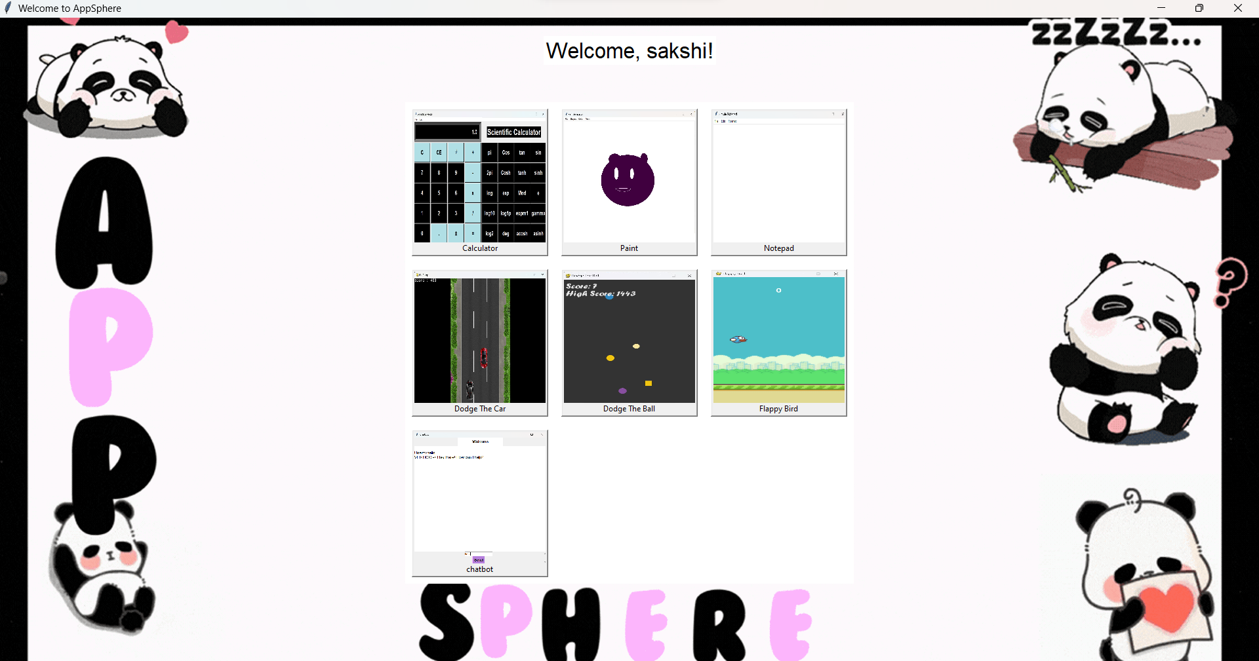
4.3.6 Scientific Calculator Interface: This is a Python implementation of a scientific calculator using the Tkinter library. Tkinter is a standard GUI (Graphical User Interface) toolkit for Python, and it allows developers to create desktop applications with ease. The calculator provides various mathematical functions beyond simple arithmetic operations, making it useful for students, professionals, and anyone requiring complex calculations.
- Standard Functions: These typically include basic arithmetic operations like addition, subtraction, multiplication, and division, along with functions like square root and percentage calculations.
- Scientific Functions: These expand upon standard functions and include more advanced operations commonly used in mathematics, engineering, and science. Examples include trigonometric functions (sine, cosine, tangent), logarithmic functions, exponential functions, factorial, and more.

Standard calculator:
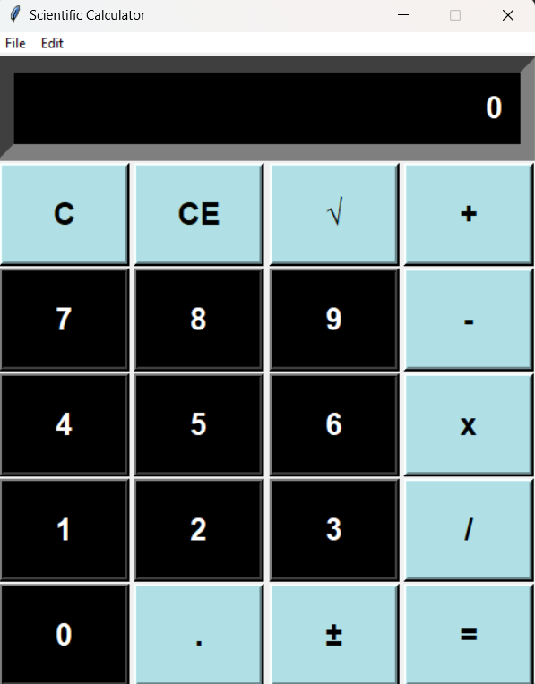
Scientific Calculator:
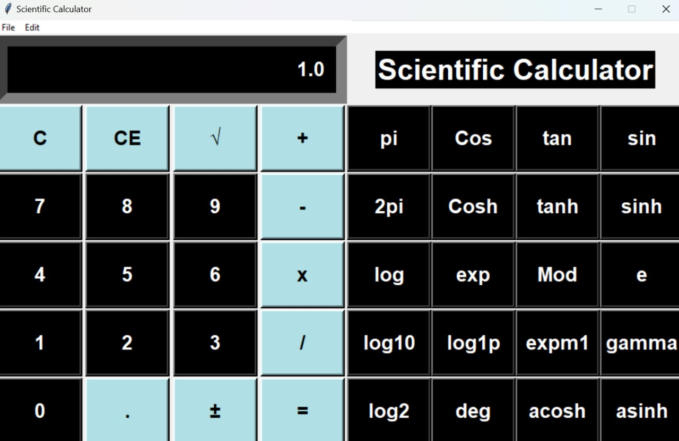
There are two options available standard and scientific when scientific calculator is clicked then scientific calculator is opened until the standard calculator is open
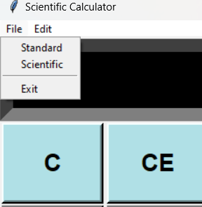
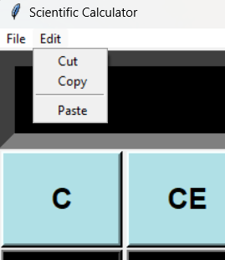
4.3.7 Dodge the Car (Initial): Dodge the Car" is a classic arcade-style game where players control a character on the screen and must navigate through a continuous stream of oncoming cars. The primary objective is to avoid colliding with these cars for as long as possible, as colliding with even a single car typically results in the game ending.The game typically starts with the player controlling a character positioned at the bottom of the screen. As the game progresses, cars of varying sizes and speeds approach from the top of the screen towards the player's character. The player must maneuver their character left or right to avoid these oncoming cars.
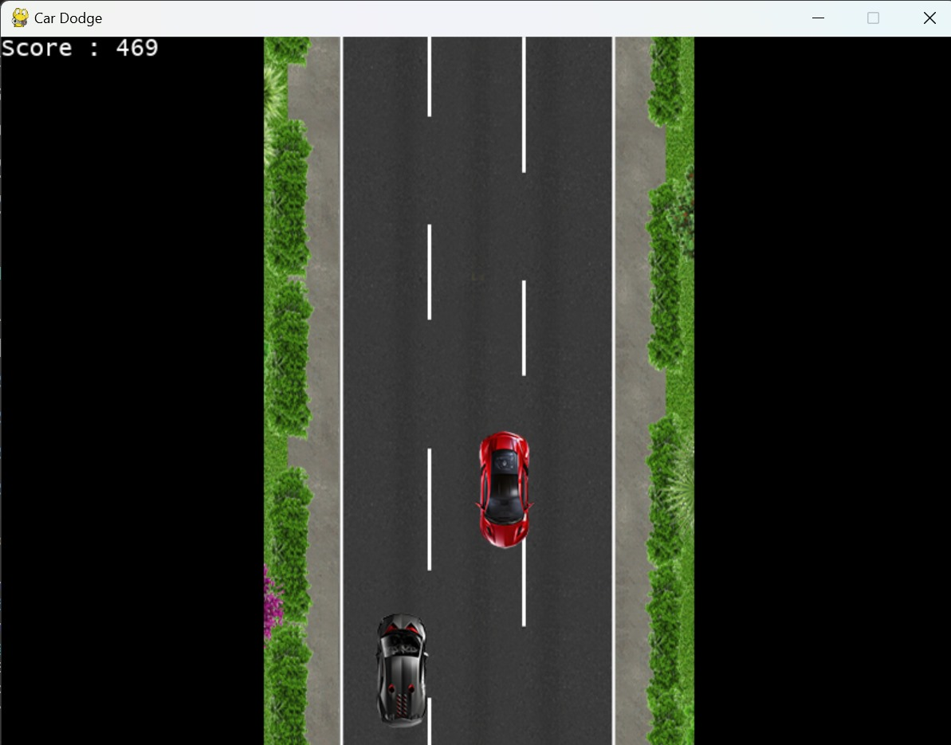
The speed of the car increases when the high score increases, and when you can't dodge any cars, it's game over. The high score is displayed and stored in a "scores.txt" file.
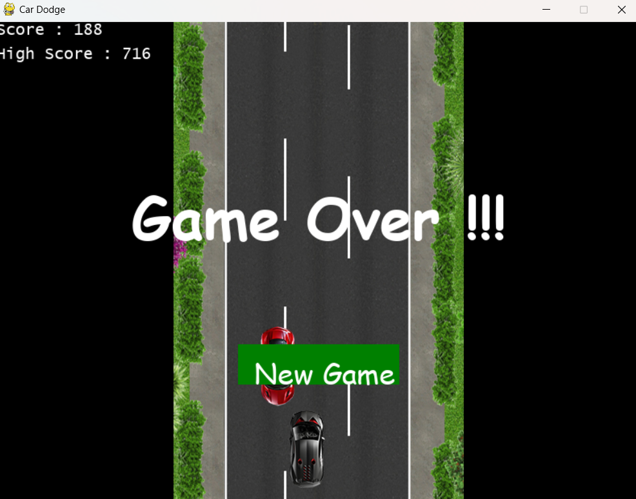
Displays Current score and high score
4.3.8 Flappy Bird: Flappy Bird's gameplay is best described as simple, addictive, yet mildly infuriating. Tap carefully to raise the bird up and navigate through the gaps in the green pipes without crashing. When the inevitable crash occurs, you'll earn a score that you can try and outdo on your next run. Game Objective:
Initial game While open: The objective is simple: keep the bird flying for as long as possible by passing it through the pipes. Each pipe successfully passed through earns you a point. The game ends when the bird collides with a pipe or falls to the ground.
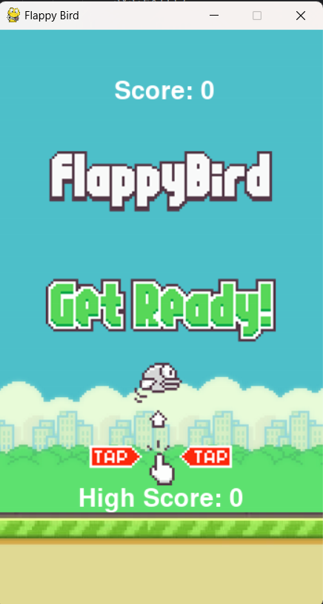
A snapshot of a player while playing the game: Controls: Tap anywhere on the screen to make the bird flap its wings and ascend. Timing your taps is crucial to maintain altitude and avoid obstacles. Mastering the controls is the key to achieving high scores and dominating the leaderboard.
In this below image the bird is flying by
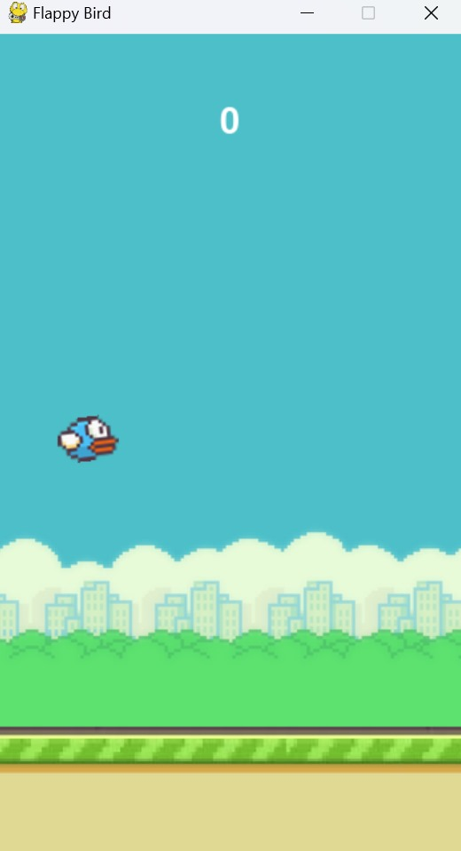
4.3.9 Dodge the Ball Game in Action: In "Dodge the Ball," the objective is typically to avoid incoming balls for as long as possible to achieve the highest score. In game screenshot with the player dodging multiple moving balls and collecting targets.

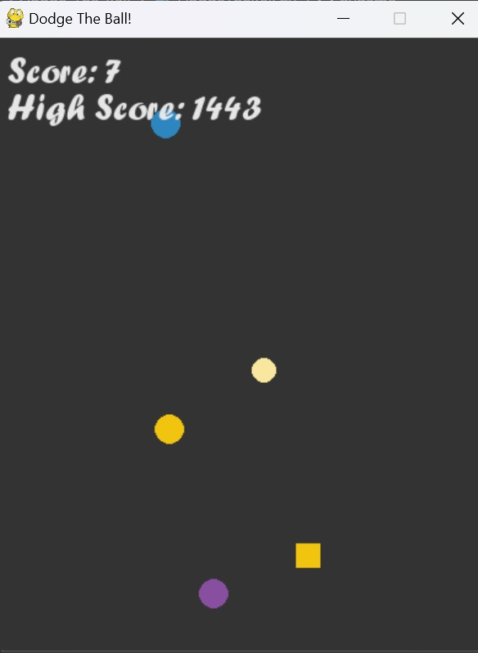
4.3.10 Notepad Interface: The Notepad application in this multi-functional platform provides users with basic text editing functionalities. It is designed to be straightforward and user-friendly, enabling users to create, edit, and save text documents with ease.
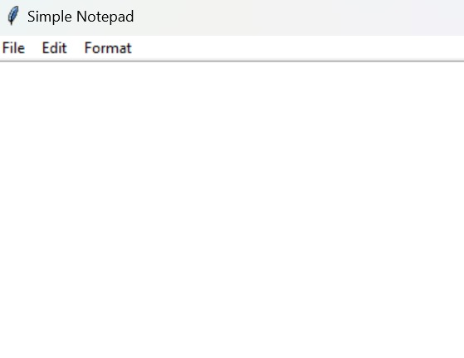
- Title Bar:
Displays the title "Simple Notepad," indicating the name of the application.
- Menu Bar:
The menu bar at the top of the interface includes three primary menus: File, Edit, and Format.
- File Menu:
Contains options for file operations such as creating a new document, opening an existing document, saving the current document, saving the document with a new name (Save As), and exiting the application.
- Edit Menu:
Provides options for editing the text within the Notepad. Common functions include undo, redo, cut, copy, paste, and select all.

- Format Menu:
Includes options for formatting the text, such as changing the font style, size, and other text properties.
- Text Area:
- File Menu :The large white area is the text area where users can type and edit their text. It is the main workspace of the Notepad application.

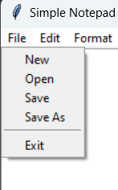

File Menu
The File menu (second image) provides several essential file operations:
- New: Creates a new blank document.
- Open: Opens an existing document from the file system.
- Save: Saves the current document.
- Save As: Saves the current document with a new name or to a new location.
- Exit: Closes the application.

- Edit Menu :The Edit menu in the Notepad application is designed to provide essential text manipulation functionalities. Below is a detailed explanation of the typical options found under the Edit menu in a basic text editor like the one depicted:

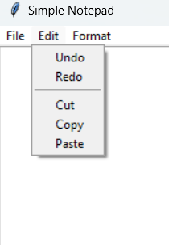
Edit Menu Options
- Undo:
Reverses the last action performed. This is useful for quickly correcting mistakes.
Shortcut: Ctrl + Z
- Redo:
Re-applies the last action that was undone. This is the opposite of the Undo function.
Shortcut: Ctrl + Y
- Cut:
Removes the selected text from the document and places it on the clipboard, allowing you to paste it elsewhere.
Shortcut: Ctrl + X
- Copy:
Copies the selected text to the clipboard without removing it from the document, so you can paste it elsewhere.
Shortcut: Ctrl + C
- Paste:
Inserts the text from the clipboard into the document at the current cursor position.
Shortcut: Ctrl + V
- Format: The Format menu in the Notepad application provides options to customize the appearance of the text within the document. Below is a detailed explanation of the typical options related to font size, text color, and text font found under the Format menu:

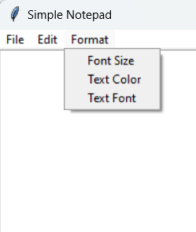

Format Menu Options
- Font Size:
Allows the user to change the size of the selected text or all the text in the document.
Users can select from a list of predefined font sizes or enter a custom size.

- Text Color:
Allows the user to change the color of the selected text.
Users can choose from a color palette or enter custom color values (e.g., RGB or HEX codes).
Changing the text color can be used for emphasis, categorization, or aesthetic purposes.
- Text Font:
Allows the user to change the font type of the selected text or all the text in the document.
Users can select from a list of installed fonts on their system.
Changing the text font can enhance readability, convey a particular style, or fit a document's theme.
4.3.11 Paint Application Interface
The Paint Application Interface allows users to create and manipulate graphical images using various tools and options. Below is a detailed explanation of the key features commonly found in a Paint application, including the File menu, shape tools, and color tools.
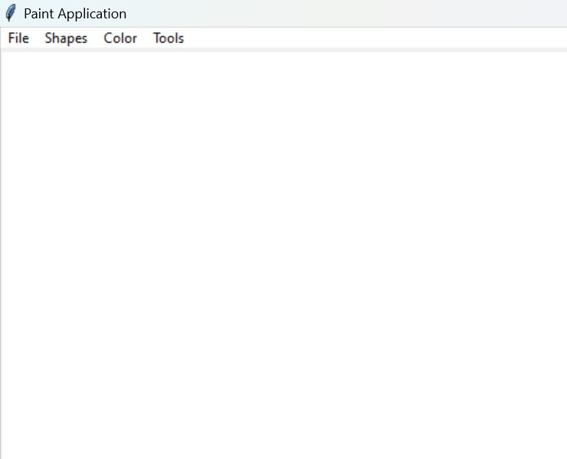
- File Menu:
- New: Clears the current canvas and starts a new blank canvas.
- Open: Allows the user to open an existing image file from their computer.
- Save: Saves the current image to a file.
- Save As: Saves the current image to a new file with a specified name and format.
- Exit: Closes the Paint application.
- Shape Tools:
Allows the user to draw predefined shapes on the canvas.
Common shapes include:
- Rectangle: Draws a rectangle or square.
- Ellipse: Draws an ellipse or circle.
- Line: Draws a straight line.
- Polygon: Draws a multi-sided shape.
Users can select a shape tool and then click and drag on the canvas to draw the shape.
- Color Menu:
- Color Picker: Choose specific colors to match branding or design requirements.
- Preset Colors: Quickly switch between commonly used colors.
- Fill Color: Fill shapes with solid colors or gradients.
- Stroke Color: Outline shapes with contrasting colors for emphasis.
- Tool Menu:
- Pencil/Brush: Draw freehand artwork or add details to shapes.
- Eraser: Correct mistakes or remove parts of the drawing.
- Text: Add labels, titles, or annotations to your drawing.
- Fill: Quickly color enclosed areas without manually shading.
- Shape:
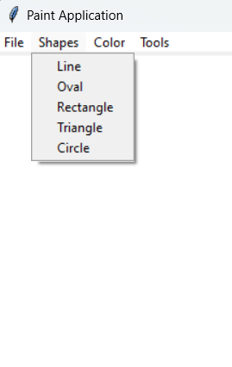

- Line Tool
Functionality: Draws a straight line between two points.
Usage:
Select the Line tool from the shape options.
Click on the canvas to set the starting point of the line.
Drag the mouse to the desired endpoint and release the mouse button to complete the line.
Applications: Useful for creating straight lines, underlining text, dividing sections, and more.
2. Rectangle Tool
Functionality: Draws a rectangle or square.
Usage:
Select the Rectangle tool.
Click on the canvas to set one corner of the rectangle.
Drag the mouse diagonally to the opposite corner and release the mouse button to complete the rectangle.
Applications: Commonly used for creating boxes, frames, backgrounds, and various other rectangular shapes.
3. Oval Tool
Functionality: Draws an ellipse or circle.
Usage:
Select the Oval tool.
Click on the canvas to set one corner of the bounding box for the oval.
Drag the mouse to the opposite corner of the bounding box and release the mouse button to complete the oval.
Applications: Used for drawing ovals, circles, and rounded shapes for decorative purposes, diagrams, and more.
4. Circle Tool
Functionality: Draws a perfect circle.
Usage:
Select the Circle tool (if distinct from the Oval tool, otherwise use the Oval tool with a modifier key like Shift to maintain aspect ratio).
Click on the canvas to set the center point of the circle.
Drag the mouse outward while holding the Shift key to create a circle with equal height and width.
Release the mouse button to complete the circle.
Applications: Ideal for creating circular shapes, buttons, icons, and more.
5. Triangle Tool
Functionality: Draws a triangle.
Usage:
Select the Triangle tool.
Click on the canvas to set one vertex of the triangle.
Drag the mouse to define the base and height of the triangle and release the mouse button to complete the shape.
Some tools might require clicking three points to define the vertices of the triangle.
Applications: Useful for creating triangular shapes, arrows, design elements, and more.

3. Color:The Paint Application interface includes color options that allow users to choose different colors for their drawings. These color options typically include tools for selecting stroke (outline) color and fill color, which can be applied to shapes and lines. Here is a detailed explanation of how these color options can be used:

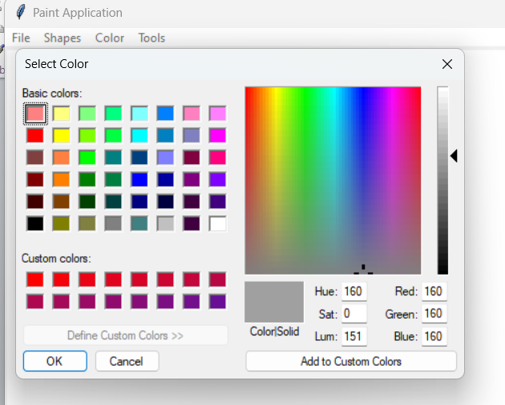

1. Stroke Color
Functionality: Sets the color of the outline (or stroke) of shapes and lines.
Usage:
- Open the color menu and select the "Stroke Color" option.
- A color chooser dialog box will appear, allowing the user to pick a color.
- Once a color is selected, it will be used for the outline of all subsequent shapes and lines drawn on the canvas.
Applications: Useful for customizing the appearance of shapes and lines by changing their border color.
2. Fill Color
- Functionality: Sets the color used to fill the interior of shapes.
Usage:
- Open the color menu and select the "Fill Color" option.
- A color chooser dialog box will appear, allowing the user to pick a color.
- Once a color is selected, it will be used to fill the interior of all subsequent shapes drawn on the canvas.
Applications: Useful for adding color to the interior of shapes like rectangles, ovals, circles, and triangles, enhancing their visual appeal.

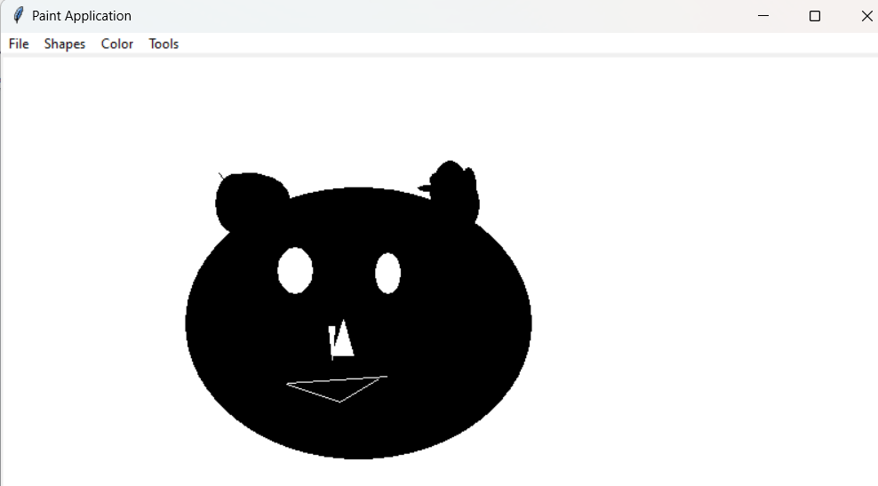
4.3.12 Chatbot : The Chatbot interface in the project is designed to provide a simple and user-friendly platform for interacting with a conversational agent. Here's a detailed explanation of the different components and their functionalities:
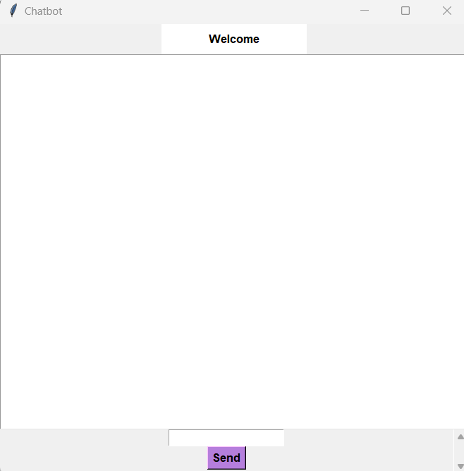

1. Main Window
- Welcome Message: At the top of the interface, there is a "Welcome" message. This message can be customized to greet users and provide a friendly introduction to the chatbot.
- Chat Display Area: The large white area beneath the welcome message is the chat display area. This is where the conversation between the user and the chatbot is displayed. It shows the messages from both the user and the chatbot, typically in a conversational format with timestamps.
- Scroll Functionality: The chat display area likely has scroll functionality to allow users to view previous messages in the conversation.
2. Input Field
- User Input Field: At the bottom of the interface, there is a text input field where users can type their messages or queries to the chatbot. This field is the primary way for users to interact with the chatbot.
- Placeholder Text: The input field might include placeholder text (e.g., "Type your message here...") to guide users on where to enter their text.
3. Send Button
- Send Button: Adjacent to the input field is the "Send" button. Users click this button to send their typed message to the chatbot.
- Functionality: When the "Send" button is pressed, the message in the input field is transmitted to the chatbot for processing. The chatbot's response is then displayed in the chat display area.
Usage and Interaction
- Initiating a Conversation:
The user types a message in the input field.
The user clicks the "Send" button to send the message.
The chatbot processes the message and provides a response, which is displayed in the chat display area.
- Continuing the Conversation:
The conversation continues with the user typing subsequent messages and clicking "Send."
The chatbot's responses appear in real-time, creating an interactive dialogue.
- Customizable Welcome Message:
The welcome message can be customized to include specific instructions, greetings, or prompts to enhance the user experience.

After some chat:
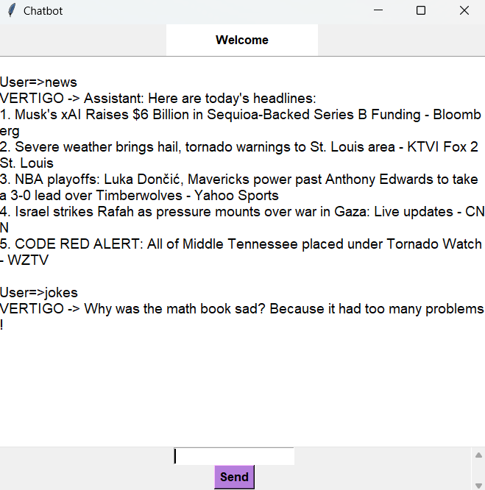

The Chatbot interface in action, showing a series of interactions between the user and the chatbot. Here is a detailed explanation of the different components and their functionalities, as well as the example interaction illustrated in the image.

1. Chat Display Area
- Welcome Message: At the top of the interface, there is a "Welcome" message, greeting the user and setting a friendly tone for the conversation.
- Conversation History: Below the welcome message, the chat display area shows the history of the conversation. Each message is prefixed with "User=>" for user inputs and "VERTIGO ->" for the chatbot's responses.
- Scrollable View: The chat display area is scrollable, allowing users to view previous messages by scrolling up and down.
2. User Input Field
- Text Entry Field: Located at the bottom of the interface, the user input field is where users type their messages or queries to the chatbot.
- Placeholder: The input field might include placeholder text to guide users, but it's not visible in this specific screenshot.
3. Send Button
- Send Button: Adjacent to the input field is the "Send" button. Users click this button to send their typed messages to the chatbot.
- Functionality: Clicking the "Send" button transmits the message in the input field to the chatbot for processing. The chatbot's response is then displayed in the chat display area.
Example Interaction
News Query
User Input: User=>news
The user types "news" to request the latest news headlines.
Chatbot Response: VERTIGO -> Assistant: Here are today's headlines:
The chatbot, named "VERTIGO," responds with a list of current news headlines from various sources.
Example Headlines:
Musk's xAI Raises $6 Billion in Sequoia-Backed Series B Funding - Bloomberg
Severe weather brings hail, tornado warnings to St. Louis area - KTVI Fox 2 St. Louis
NBA playoffs: Luka Dončić, Mavericks power past Anthony Edwards to take 3-0 lead over Timberwolves - Yahoo Sports
Israel strikes Rafah as pressure mounts over war in Gaza: Live updates - CNN
CODE RED ALERT: All of Middle Tennessee placed under Tornado Watch - WZTV
Joke Query
User Input: User=>jokes
The user types "jokes" to request a joke from the chatbot.
Chatbot Response: VERTIGO -> Why was the math book sad? Because it had too many problems.
The chatbot responds with a joke, showcasing its ability to provide light-hearted entertainment.

Chapter:5
PROJECT TESTING

5.1 Introduction
The testing phase is crucial for ensuring the integrated multi functional platform operates correctly and provides a seamless user experience. This phase involves different levels of testing to identify and resolve any issues before the platform is released. Thorough testing ensures the reliability, accuracy, performance, and user satisfaction of the platform.
5.2 Testing Levels
Unit Testing
- Objective: To test individual components or functions of the platform, such as specific calculator operations, game mechanics, or text editor functions, to ensure they work as expected.
- Scope: Conducted by developers, focusing on small, isolated pieces of functionality within the platform.
Integration Testing
- Objective: To verify that different components of the platform, such as the scientific calculator, games, clock display, text editor, paint application, and desktop assistant, work together seamlessly.
- Scope: Includes testing interactions between various features and ensuring consistent data handling using SQLite.
System Testing
- Objective: To test the entire platform as a whole to ensure it meets the defined requirements and performs well under various conditions.
- Scope: Comprehensive testing of all functionalities, including calculator operations, gameplay, document management, drawing features, voice commands, and more.

5.3 Testing Techniques
Manual Testing
- Exploratory Testing: Manually navigating through the platform to identify any unexpected behaviors or bugs.
- Test Case Execution: Manually executing predefined test cases to verify specific functionalities and scenarios.
Automated Testing
- Unit Tests: Writing automated tests for individual functions or components using appropriate testing frameworks.
- End to End Tests: Using tools like Selenium or Cypress to automate the testing of user workflows, such as switching between applications, performing calculations, playing games, and using the desktop assistant.
5.4 Test Cases for Testing the Project
Test Case 1: Scientific Calculator Basic Operations
Objective: Ensure the scientific calculator performs basic arithmetic operations correctly.
Steps:
1. Open the scientific calculator.
2. Enter numbers and perform addition, subtraction, multiplication, and division.
3. Verify the results of each operation.
Expected Result: The calculator should return accurate results for all basic arithmetic operations.
Test Case 2: Car Racing Game
Objective: Verify the functionality of the car racing game.
Steps:
1. Start the car racing game.
2. Control the car using keyboard inputs.
3. Observe the generation of enemy cars and the scrolling background.
4. Verify collision detection and score tracking.
Expected Result: The game should have responsive controls, generate enemy cars randomly, detect collisions accurately, and track scores correctly.

Test Case 3: Dodge The Ball Game
Objective: Ensure the dodge the ball game operates as expected.
Steps:
1. Start the dodge the ball game.
2. Control the pointer using mouse movement.
3. Observe the random movement of balls.
4. Verify collision detection and point scoring mechanism.
Expected Result: The pointer should move smoothly, balls should move randomly, and the game should accurately detect collisions and score points.

Test Case 4: Flappy Bird Replica
Objective: Verify the functionality of the Flappy Bird replica game.
Steps:
1. Start the Flappy Bird replica game.
2. Control the bird using spacebar input.
3. Observe the random generation of pipes.
4. Verify collision detection and score tracking.
Expected Result: The bird should respond to spacebar inputs, pipes should be generated randomly, and the game should detect collisions and track scores accurately.
Test Case 6: Text Editor
Objective: Verify the functionality of the text editor.
Steps:
1. Open the text editor.
2. Create a new document and enter text.
3. Perform cut, copy, paste, and undo/redo actions.
4. Adjust font size and save the document.
5. Open the saved document to verify contents.
Expected Result: The text editor should support text manipulation, font adjustment, and reliable document saving and opening.
Test Case 7: Paint Application
Objective: Ensure the paint application works as expected.
Steps:
1. Open the paint application.
2. Draw on the canvas using various tools (pen, eraser).
3. Select different brush sizes, colors, and pen types.
4. Save and clear the drawing.
5. Open the saved drawing to verify its contents.
Expected Result: The paint application should allow smooth drawing, tool selection, and reliable saving and opening of drawings.

Test Case 8: Desktop Assistant
Objective: Verify the functionality of the desktop assistant.
Steps:
1. Activate the desktop assistant.
2. Issue voice commands for tasks such as retrieving weather updates, playing music, and providing news headlines.
3. Verify text and speech responses.
Expected Result: The desktop assistant should accurately recognize voice commands, perform tasks, and provide appropriate responses.

Chapter:6
CONCLUSION

Conclusion
In conclusion, the development of the multi functional platform successfully integrated a variety of applications, including a scientific calculator, interactive games, a text editor, a paint application, and a desktop assistant, into a cohesive and user friendly interface. This project demonstrated the effective use of Python and its libraries to create a versatile, efficient, and scalable application. Despite the complexities involved in integrating diverse functionalities, the platform achieved smooth performance, aesthetic design, and robust user experience. Comprehensive testing and thoughtful design ensured reliability and security, while future enhancements have been planned to further improve and expand the platform's capabilities. Overall, this project exemplifies a well rounded approach to software development, providing valuable tools and entertainment within a single, unified application.

6.1 References
- Chatgpt: https://chatgpt.com/?oai dm=1
- W3schools: https://www.w3schools.com/
- Geeksforgeeks: https://www.geeksforgeeks.org/
- Youtube: https://www.youtube.com/
6.2 List of Abbrevation
- AS: AppSphere
- DFD: Data Flow Diagram
- FS: Feasibility Study
- RAS: Requirements Analysis and Specifications
- RS: Requirement Specification
- IDE: Integrated Development Environment
- SQLite3: Structured Query Language Lite 3
- GUI: Graphical User Interface
- UI: User Interface
- EHA: Error Handling and Alerts

Chapter:7
Appendix

A.1 Source Code
The complete source code for the AppSphere project is available on GitHub. It includes all necessary files and setup instructions.
GitHub Repository: [major-project]( https://github.com/palak-arch/major-project.git)
A.2 Development Tools
- IDE: Visual Studio Code, PyCharm.
- Version Control: Git, GitHub.
A.3 Installation Guide
1. Clone repository:
https://github.com/palak-arch/major-project.git
2. Navigate to directory:
cd AppSphere
3. Install dependencies:
pip install -r requirements.txt
4. Run application:
python main.py

